MATLAB-BASED MODELLING OF VSB MODULATOR AND DEMODULATOR FOR ANALOG TELEVISION COMMUNICATION APPLICATIONS
Objectives:
i) To generate and analyse the Vestigial Sideband (VSB) modulated signal by performing DSB-SC modulation and applying a suitable filter using MATLAB.
ii) To implement coherent demodulation and recover the original message signal from the VSB signal, and compare the transmitted and recovered waveforms.

PROGRAM (MATLAB CODE)
clc;
clear;
close all;
% Parameters
fs = 100000; % Sampling Frequency t = 0:1/fs:0.02; % Time Vector
fm = 500; % Message Frequency fc = 5000; % Carrier Frequency
% Message Signal
m = cos(2*pi*fm*t);
% Carrier Signal
c = cos(2*pi*fc*t);
% DSB-SC Modulation
dsb = m .* c;
% VSB Filter (Low-pass + High-pass Approximation) [b,a] = butter(4, fc/(fs/2));
vsb = filter(b,a,dsb);
% Coherent Demodulation
demod = vsb .* (2*cos(2*pi*fc*t));
% Recover Message
[b1,a1] = butter(4, 1000/(fs/2));
rec = filter(b1,a1,demod);
% Display Results
figure;
subplot(5,1,1)
plot(t,m)
title('Message Signal')
grid on
subplot(5,1,2)
plot(t,c)
title('Carrier Signal')
grid on
subplot(5,1,3)
plot(t,dsb)
title('DSB-SC Signal')
grid on
subplot(5,1,4)
plot(t,vsb)
title('VSB Signal')
grid on
subplot(5,1,5)
plot(t,rec,'r')
title('Recovered Message')
grid on
output:
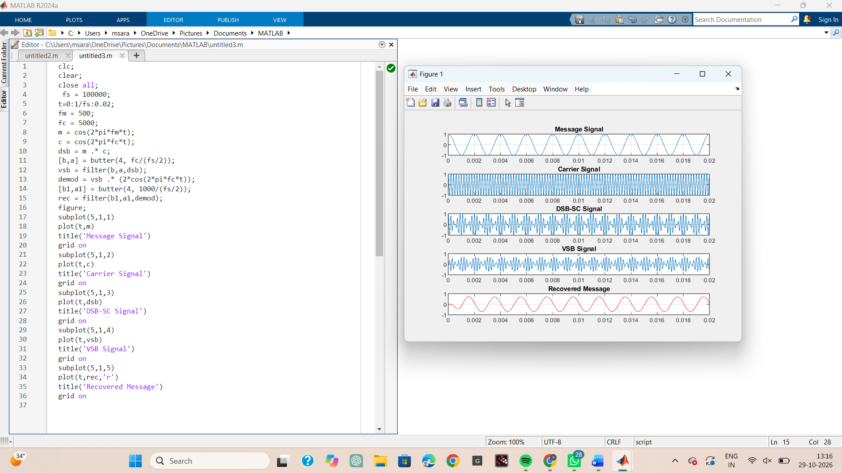
Result 1:
i) The VSB modulated signal was successfully generated from the DSB-SC signal using MATLAB and verified through the displayed waveforms.
ii) The original message signal was successfully recovered through coherent demodulation and low-pass filtering, confirming the correct implementation of the VSB communication system.

